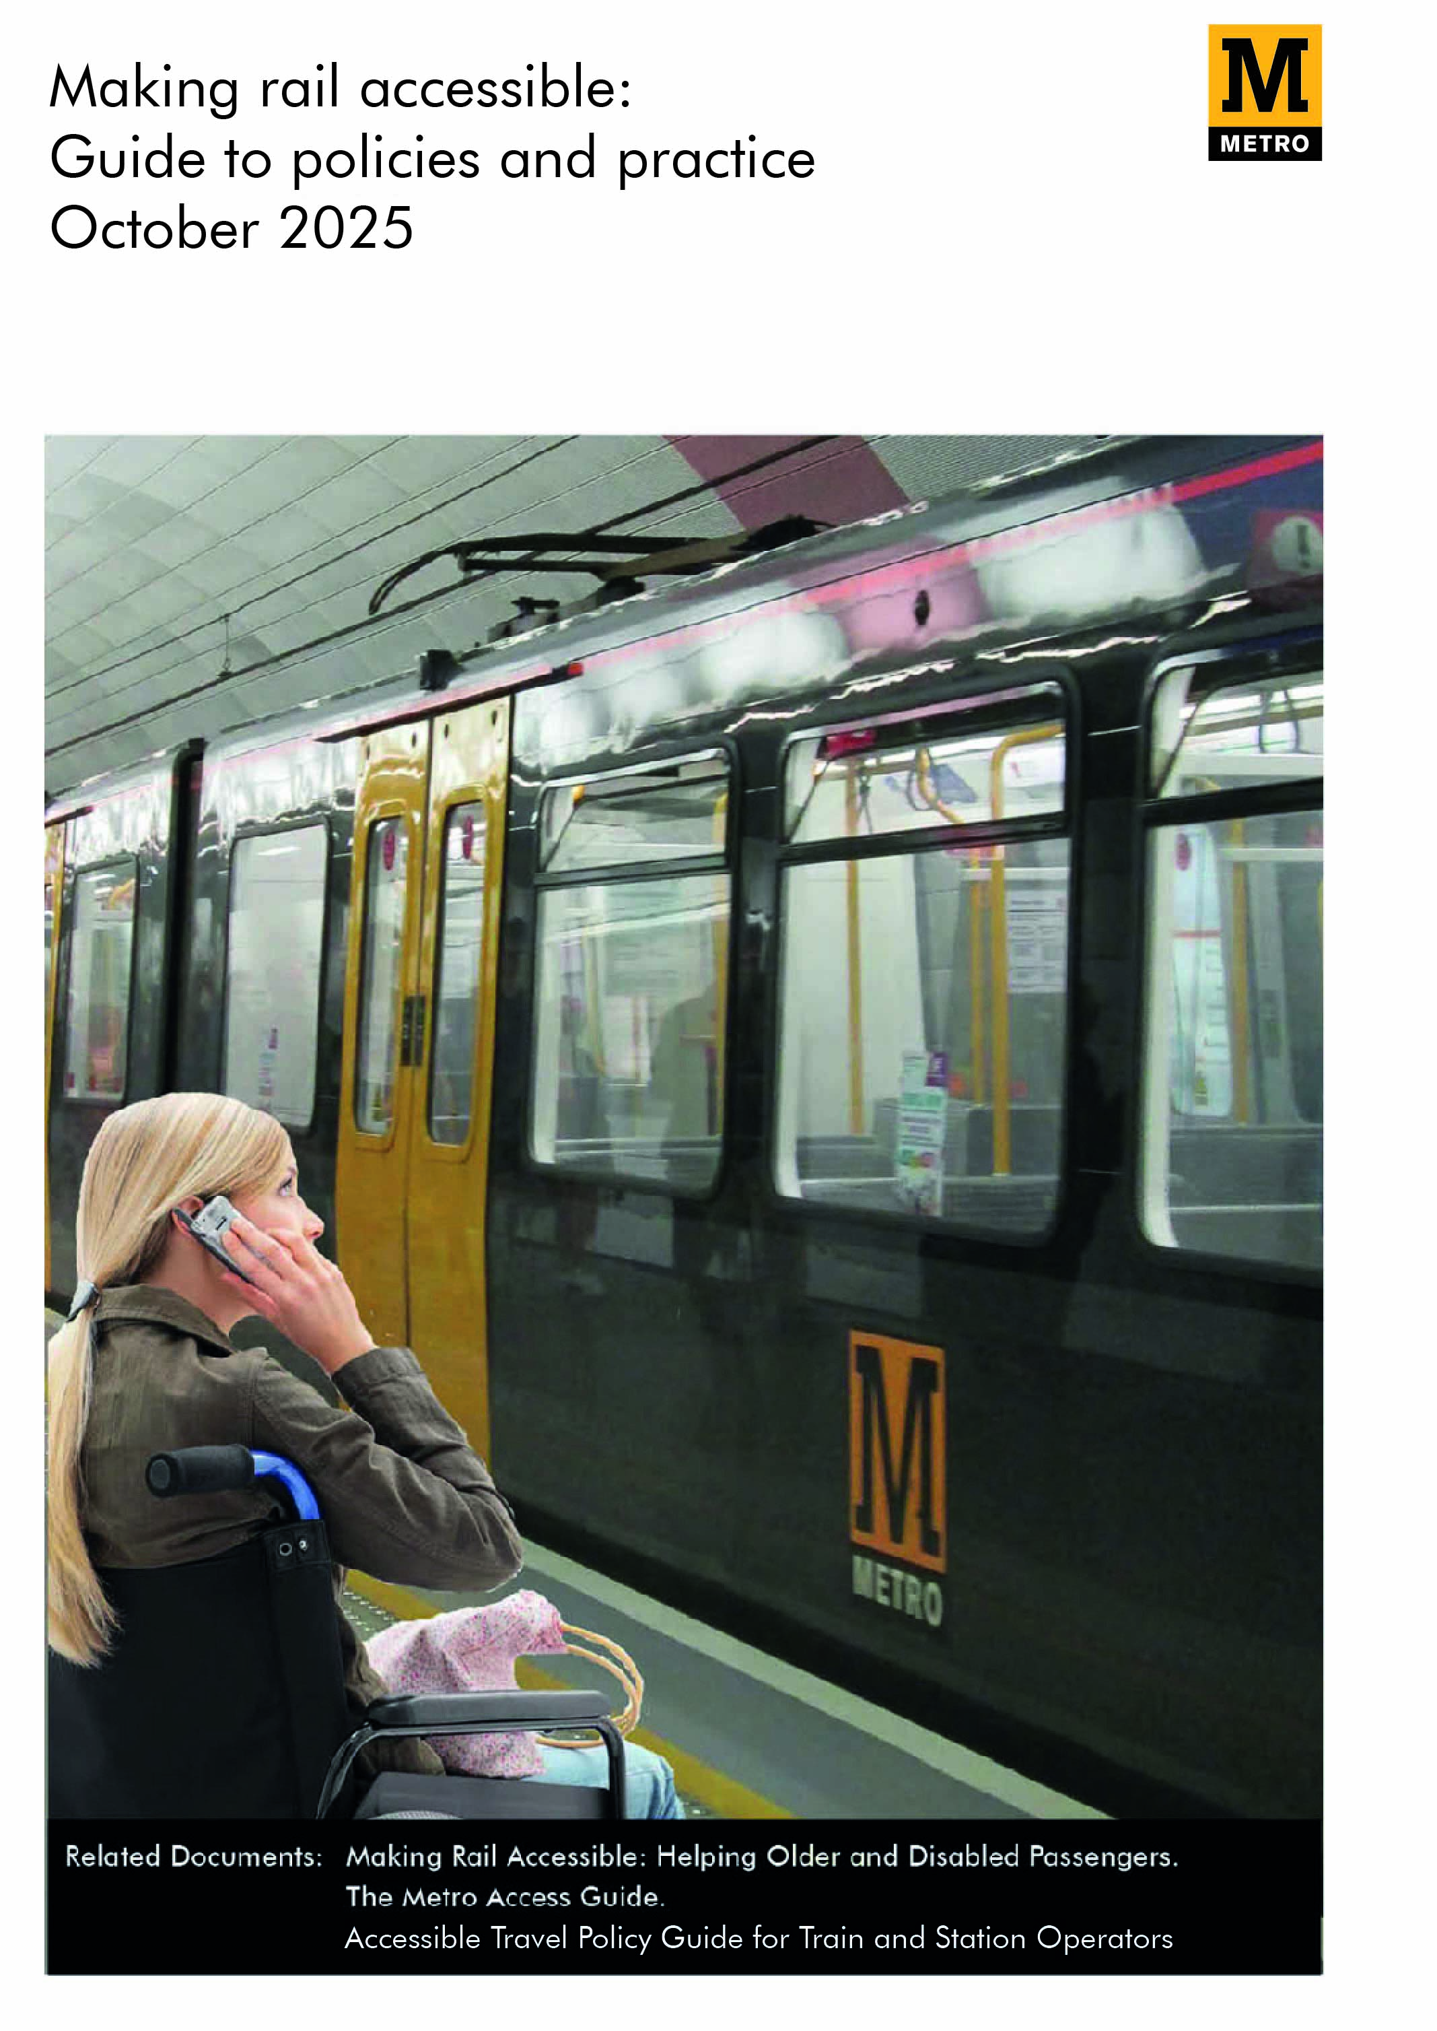
Figure 1

1. Our Strategy
We aim to maintain and improve current standards of accessibility to services for people with disabilities or whose mobility is impaired. We will take account of provisions within the Equality Act 1998 working with other rail industry partners and stakeholders wherever possible. We aim to deliver a high standard of care to all our customers.
This document has been prepared with reference to the Department for Transport (DfT) publication “How to write your Disabled People’s Protection Policy“ (issued November 2009), Office of Rail and Road statement in the matter (issued July 2014) and their Accessible Travel Policy Guide for Train and Station Operators (issued September 2020).
It is a ‘live’ document and is always under development. We will carry out a full review annually with any version containing material changes being submitted for approval to the Office of Rail and Road. The Office of Rail and Road will also carry out an annual review of this document, regardless of any changes, to ensure it remains accurate and compliant.
2. Management Arrangements
We aim to provide easy access and excellent customer service for all our customers. All members of our Customer Services teams have a duty to provide assistance and information to customers with assistance needs and to feedback improvement ideas to make the service we provide better.
The Metro Operations Director will lead on the policy at Senior Leadership level. The Head of Metro Customer Service will have responsibility for implementing the policy and assisted by the Station Delivery Manager will carry out a monthly review of correspondence. The Metro Operations Director, assisted by the Head of Metro Customer Service, will also lead the annual review of the policy.
We use several methods to communicate the policy to frontline teams. Our team briefing process provides a high-level brief to all employees of the company regardless of their role and this is supported by face-to-face briefing by line managers. Any significant changes to the Policy are briefed out face-to-face, this process allows face-to-face feedback.
3. Monitoring and Evaluation
In order to monitor progress and compliance, all complaints, queries and compliments are recorded by the Customer Relations Manager and reviewed by the Station Delivery Manager, either as part of a monthly trend report or immediately on receipt. This ensures the effectiveness of our policies and practices are monitored over time and that any day-to-day issues are identified and resolved as quickly as possible.

On a day-to-day basis, the Customer Service Manager will review all Customer Assistance Reservations to ensure they have been made correctly and that the appropriate assistance can be provided at all locations around the Metro system.
The Customer Relations Manager manages the key KPIs which are as follows:
• Total number of assistance requests
• Total number of no-show customer and employees
• Number of complaints received regarding assistance
Any actions arising against these are monitored periodically. KPIs have been agreed between the Customer Relations Manager and the Station Delivery Manager.
An annual review of this policy will take place, and a report will be sent to the Office of Rail and Road on each anniversary, if any major changes have been made. We will detail progress made in achieving objectives and any difficulties experienced with the implementation of the policy.
4. Access Improvements
The stations on the Metro system range from modern to those originating from British Rail and Victorian times, many of these stations have undergone major asset renewal of the past 17 years.
We are committed to making every possible effort to meet the Department for Transports code of practice on the design standards for accessible railway stations (valid from March 2015). Wherever possible we will adopt a best-practice approach to providing access for disabled customers.
As part of the 11-year Metro Asset Renewal Programme considerable improvements have been made at several stations across the Metro network since 2010. Proposals are being developed for continuing the investment programme through to 2031.
Replacement of the current fleet of Metro trains will commence in late 2024 and run through to 2026. The new fleet will be compliant with the Rail Vehicle Accessibility Regulations 2010. This will ensure that Metro will continue to be available for decades to come.
Of the current fleet of ninety cars, eighty-six have undergone a planned refurbishment, ensuring compliance to the Rail Vehicle Accessibility Regulations 2010. The remaining four un-refurbished Metrocars are accessible to wheelchair users and customers with mobility impairments. Although not fully compliant these Metrocars have exemptions from the Department for Transport, allowing them to remain in service.

We acknowledge that the horizontal gaps between the platform and the train at some locations are larger than others. This occurs at curved platforms such as Tynemouth and Stadium of Light. There is an ongoing programme to ensure all platform gaps remain within specification and that they are checked at least every year. The new rolling stock has been fitted with step plates, further reducing the gap between the train and platform edge.
In addition, arrangements are made for the provision of portable boarding ramps so that wheelchair users booking assistance for their journey to our stations, including the 11 licensed stations on the Sunderland Line, can be offered this facility. Northern Rail, as the Station Facility Operator, already provide this facility at Sunderland station.
Once the new fleet of Metrocars are fully introduced we anticipate that the requirement for portable boarding ramps will be limited to Sunderland station platform and Fellgate only due to the step height between the train and the platform edge.
Our Metro Access Guide is available online, it outlines the facilities and access available at all stations on the Metro network. This guide can be found on the Metro website at nexus.org.uk/metro/access-all.
5. Working with Others
We will work closely with organisations such as the Rail Ombudsman, Transport Focus, and representative disability groups to continuously understand and improve the levels of service we offer to older and disabled customers.
Specifically, Metro will liaise with relevant disability groups when we plan upgrades to our facilities, including stations, trains and retail mechanisms. We have a database of local groups and organisations, and this includes umbrella bodies such as the North Tyneside Coalition of Disabled People and Newcastle Disability Forum, as well as organisations representing specific interests, such as Guide Dogs or RNIB. Further details of groups are available through Nexus’s annual equality & diversity report.
6. Employee Training
All our Customer Service Teams are provided with disability awareness training, which covers how they can support customers with a visual and/or hearing impairment, learning difficulty and/or physical impairment while they are travelling on Metro.
Our customer service training includes the appreciation of the widest definition of ‘disability’. This includes temporarily disabilities through illness, injury or surgery, people with learning difficulties, impaired vision or speech impediments, and wheelchair users.
We also look at unseen disabilities such as dyslexia, dementia, anxiety, autism and how such disabilities can affect customers’ interaction with Customer Service Teams while travelling by train.
We strive to ensure that our employees effectively and considerately communicate with customers who have visual impairments, are deaf or hard of hearing, are without speech or have a speech impairment, people with dementia or learning difficulties and with other cognitive or neurodiversity. Our employees will have the correct competencies to communicate effectively, so any user travelling on Metro can be given advice on using the system and receive an enhanced customer experience.
Our employees receive training which covers assisting wheelchair users and methods of recognising and communicating with people with different disabilities.
To further support effective communication, The British Sign Language leaflet and basic sign language guides are available on our Customer Services Team mobiles phones.

7. Emergency Procedures
We recognise that disabled customers may need special assistance at times of train or station evacuation. We have procedures for dealing with these events, Customer Services Teams are briefed and assessed against these procedures.
In an emergency, it is often safer for a customer to remain on the train or in a station rather than be moved. Metro teams and the emergency services will provide the necessary assistance during such an evacuation. Our passenger assistance booking system provides us with details of all customers who have pre-arranged assistance.
8. Communications Strategy
We want to make sure that information about our services is accessible. To obtain information on our services and facilities visit the Nexus website, nexus.org.uk.
Customers can contact us by telephoning Customer Relations on
0191 20 20 747 (Iines are open Monday to Friday, 9.00am-5.00pm), to find out more about Metro services, including details of planned service changes due to improvement works, and the services available at the stations.
Customers who require assistance when travelling on Metro can call 0191 20 33 666 or email assistance@nexus.org.uk (at least four working hours in advance of travelling). Where assistance is required but has not been booked in advance, we will aim to provide assistance.
A Help Point is located at every station that allows customers to speak to a member of our Customer Service Team.
We also recognise the need for our website to be accessible to all. We have implemented several features to make our website easy to use, especially for users with disabilities.
We have set out our approach to accessibility across all the web pages under our control. This includes the Metro web page.
The current Nexus website aims to comply with all the Guidelines for UK government websites, as well as all the priority 1 and 2 checkpoints to achieve compliance with the Worldwide Web Consortiums (W3C) Web Content Accessibility Guidelines (WCAG) 2.1, Level AA, and to maintain this standard as a minimum.
9. Signage
We recognise that clear and well positioned signs can make a significant improvement to the journey of customers, especially those with disabilities.
Signage located in areas surrounding the station, at the entrance to the station (Metro cube) and on stations and trains takes disability requirements into account and is all contained within our internal Metro Design Guide to ensure consistency and clarity of information for customers.
We are obligated to display certain signage around the system in specific places and in doing so take disabled customers into consideration. Initiatives such as posters displaying information related to onward travel by other means of transport ensure customers are well informed about the possibilities of integrating with other methods of travel where needed.
10. Car Parking
To make travelling by Metro more convenient, consideration has been given to the location and number of parking spaces designated for use by people with disabilities. Our Metro Access Guide lists the locations where disabled parking can be found.
Further information on car park opening times and total spaces available can be found on the Metro website nexus.org.uk/park.

11. Contact Information
Customer Relations
- Letter
Nexus
Customer Relations
The Spark
Newcastle Helix
St James Boulevard
Newcastle upon Tyne
NE4 5DE
- Phone: 0191 20 20 747 (lines are open Monday to Friday, 9.00am-5.00pm)

- Email: customerrelations@nexus.org.uk

- Online: nexus.org.uk/metro

If after contacting us the matter has not been resolved to your satisfaction and you wish to take the matter further, please contact The Rail Ombudsman.

The Rail Ombudsman
The Rail Ombudsman are there to help resolve on-going complaints It’s free to use their services and they are independent of the rail industry.
The Rail Ombudsman can be contacted via their website railombudsman.org/contact-us or in any of the following ways:
Write to: FREEPOST - RAIL OMBUDSMAN
Call: 0330 094 0362 (Monday to Friday 9.00am – 5.00pm)
Textphone: 0330 094 0363
Email: info@railombudsman.org
Twitter: @RailOmbudsman

